Introduction
qDslrDashboard is an application for controlling (tethering) Nikon and Canon DSLR (latest version also works with some of the Sony mirror-less models). It uses the PTP and PTP/IP protocol for communication. Devices can be connected with USB or over the network (wired/wireless). It supports multiple DSLR connections.
qDslrDashboard works on following platforms: Android, iOS, Linux, OSX and Windows. It can be downloaded from: http://dslrdashboard.info
qDslrDashboard is developed in C++ with the Qt-Framework (http://qt-project.org/) and uses libusb (http://libusb.info/) for USB communication, OpenCV (http://opencv.org/) for various image processing and libraw (http://www.libraw.org/) for RAW image processing.
For network connection (like the TP-Link MR3040) the DslrDashboardServer (ddserver) is used. It’s only purpose is to forward the PTP packets between the USB connected DSLR and qDslrDashboard over the network. It can be run on Linux or OSX machines. Combined with the OpenWRT (https://openwrt.org/) it can be used on wireless routers like the TP-Link MR3040 (http://www.tp-link.com/en/products/details/?model=TL-MR3040 ). The source code is available at: https://github.com/hubaiz/DslrDashboardServer

Connection screen
The connection screen is the first screen that is loaded when the user start the application and it is used to establish connection with the users DSLR, to switch between connected DSLR and for setting various application settings.
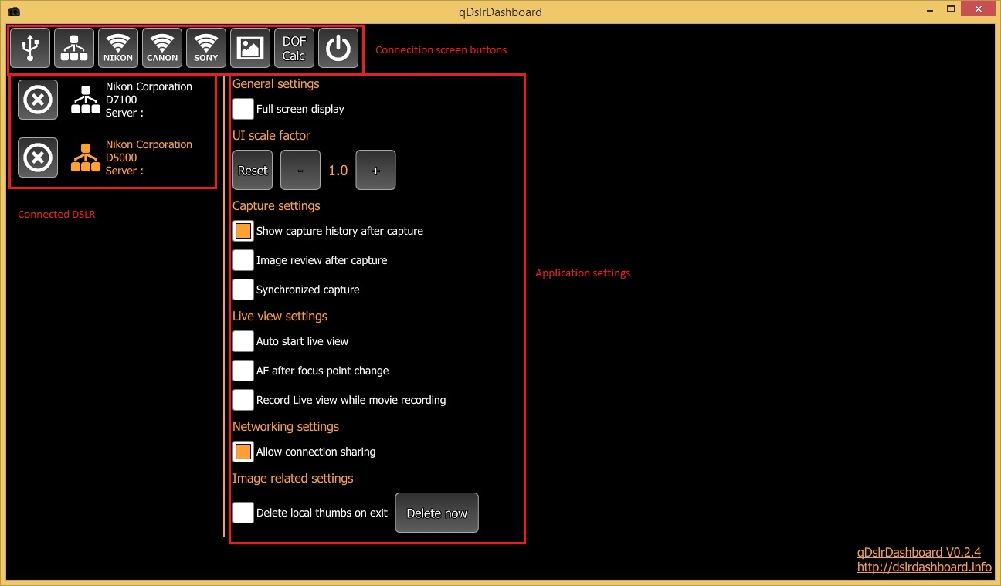

Connection screen button
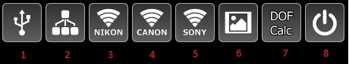
- USB connection – by pressing this button the application will search for USB connected DSLR and if it finds one it will establish a connection with it and display the device screen.
Note
  - iOS – the Applie Camera Connection Kit will not work as the API is not available for developers (maybe if Apple release it I can implement it)
  - Windows – the user must install WinUSB driver for the DSLR. See the ‘Installing the WinUSB driver’
  - Android – the Android device must have the USB Host function and an USB OTG cable/adapter must be used. Not all Android devices have the USB Host function. After the user connects the DSLR it should get a dialog with the list of application that can handle the connected USB device. If there is no dialog probably the device does not have the USB Host function (some more info: http://android.stackexchange.com/questions/36887/how-can-i-determine-if-my-device-has-usb-host-mode-otg-support ).
- Network button
  - Single press – the application will search the machine local network for DSLR that are connected to DslrDashboardServer (ddserver) or DSLR are connected to qDslrDashboard running on another machine. If a DSLR is found the application will establish a connection to it. When more DSLR are found the application will display a dialog of the discovered DSLR and the user can choose one for establishing the connection
  - Long press – the application will display a dialog where the user can enter the IP (network address) of the machine where DslrDashboardServer (ddserver) is running or IP of another machine where qDslrDashboard is running.
- Nikon wireless button - before pressing this button the user should pair the local machine wireless with the WU-1a/1b/D5300/D750 wireless.
  - Single press – the application will try to establish a connection with the WU-1a/1b/D5300/D750. If the connection is success the application will display the device screen. The application uses the default 192.168.1.1 IP (network address) when establishing the connection
  - Long press – if the user changed the IP (network address) of the WU-1a/1b/D5300/D750 wireless adapter then it can use this button. After pressing this button the application will display a dialog where the user can enter the IP (network address) of the WU-1a/1b/D5300/D750.
- Canon wireless button – before pressing this button the user should pair the local machine wireless with the Canon DSLR wireless. After pressing this button the application will try to discover the Canon DSLR and if it success it will display the device screen.
- Sony wireless button – before pressing this button the user should pair the local machine wireless with the Sony camera wireless (currently the A7 models, NEX 5, NEX6, 5000, 5100 and 6000 models should work). After the user presses this button the application will try to discover the Sony camera and if it success it will connect to it.
- Image gallery button – after pressing this button the application will display the image gallery that is used for browsing images on local machine and on the DSLR SD card. See ‘Image gallery’
- DOF calculator – after pressing this button the application will display the DOF Calculator dialog. See ‘DOF calculator’ dialog.
- Exit button – after pressing this button the application will close all the open DSLR connections and exit

Connected DSLR list
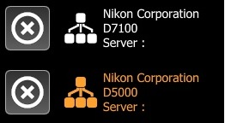
This is the list of the currently connected DSLR. It will display the connection type (USB, network, wireless) and the camera manufacturer and model. The highlighted item is the currently active camera (D5000 in this case). By pressing on the name of the camera the application will switch to the device screen for the selected camera.
Pressing the ‘X’ button will close the connection to the camera. It is recommended to always close the connection to the camera before it is turned off or unplugged.

Application settings
Some of the application settings are platform specific.

General settings
- Full screen – will switch between windowed and full screen mode.
On Android it will hide the status and navigation bar
On iOS it will hide the status bar
- Keep screen on – on Android and iOS it will prevent the screen going off
- Use ‘root’ for USB access – Android only. If the Android device is ‘rooted’ the application can try and use it during the USB connection. Can help on some Android devices that have not full USB Host function.

UI Scale factor
The application will try to determine the UI (user interface) scale factor. With the -/+ buttons the user can change this and can scale up or down the UI. With the ‘Reset’ button the user can reset back to the scale factor the application detected.

Capture settings
- Show capture history after capture – if enabled the application will display the capture history after the camera finished the capture. See ‘Capture history’
- Image review after capture – if enabled the application will download and display the capture image after the camera finished the capture. It is recommended the image format is set to RAW+JPG on camera is it is faster to download and display the JPG image. The application will always try to download and display the JPG but if the image format is set to RAW it will download and display the RAW file.
- Synchronized capture – if enabled the application will initiate the capture on all connected cameras when the device screen capture button is pressed on one of them. It will synchronously start movie recording on all connected cameras if the device screen movie recording button is pressed.

Live view settings
- Auto start live view – if enabled, after the camera connection is established the application will enable live view on the connected camera
- AF after focus point change – if enabled, while in live view if the user changes the focus point the application will start the camera auto focus
- Record live view while movie recording – if enabled, the application will save the live view stream into a local file when movie recording is started.

Network settings
- Connection sharing – if enabled, qDslrDashboard running on another device can connect and control the camera connected to this qDslrDashboard.

Image related settings
- Delete local thumbs on exit – the application stores the local image thumbnails in a folder for faster access. If this option is enabled the application will delete those files upon exit and next time the image gallery is accessed it will recreate them. The ‘Delete now’ button can be used to clear the local image thumbnails.
- Delete SD card thumbs on exit – the application stores thumbnails for the camera SD card images in a local folder. If this option is enabled the application will delete those files upon exit. Next time the user access the camera SD card in image gallery the application will download the image thumbnails. The ‘Delete now’ button can be used to clear the local thumbnails for the camera SD card images.
- Save JPG files to Photos – iOS only. If enabled, the application will add the downloaded JPG images to the Camera Roll or Photos.
- Load image infos for images already on camera SD card – the application can only access the images on camera SD card if it downloads the image info for it. If there are many images on the camera SD card this download process can take some time. By disabling this option the application in image gallery will not download the image info from the camera SD card. New capture image information will be added after capture. The user can still load the image infos from the camera SD card by pressing the ‘Refresh’ button in image gallery (see ‘Image gallery’)
- Folder for local images – here the user can select the folder for images. The application will save the images download from camera into this folder.
This option is not available on iOS platform.
- File name prefix – here the user can set the prefix that will be used for images downloaded from camera that don’t have name. If the camera does provide an image name the application will use that.
- Counter – a simple image counter that will be appended to the file name prefix when the camera does not provide a name for the downloaded image. The user can reset the counter with the ‘Reset Counter’ button.

Device screen
On the device screen the user can interact with the connect camera, change camera properties, initiate a capture, start/stop live view and movie recording.
The device screen consists of 4 parts, the left and right side buttons, the bottom area and the center live view/ OSD area.
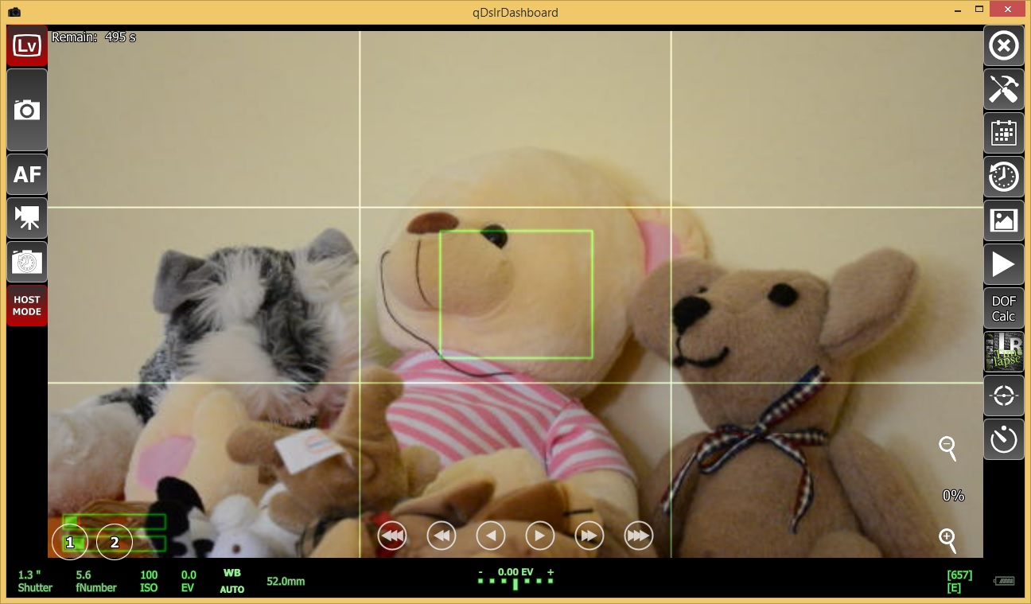

Left side buttons
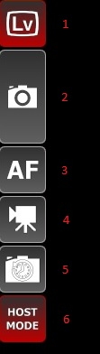
- Live view button – with this button the user can start/top the connected camera live view. If the camera live view is started the button is highlighted
- Capture button
  - Single click – will start the camera image capture with the current camera settings
Note: if the camera shutter speed is set to BULB the application will display a dialog where the user can set the BULB time. If no time is selected then the user will need to end the BULB capture
Note: not all cameras support BULB capture while connected with USB. Nikon models prior D7100 does not have the BULB capture function while connected with USB
  - Long press – will change the capture destination. By default the capture destination is the camera SD card. If the button is highlighted the capture destination is the local device and the application will after capture download the captured images and save them to the folder specified in the application settings.
- AF button
  - Single click – will start the camera auto focus if the attached lens support it and the focus mode is not MF (manual focus)
  - Longs press – will change the auto focus behavior before capture. If the button is highlighted the application will initiate the auto focus before the capture.
Note: on Nikon DSLR the camera will always try to auto focus before capture, the only exception is when the focus mode property is set to MF (manual focus). By default in application the auto focus before capture is disabled, to solve this the application will set the focus modeproperty to MF (manual focus) before capture and after the capture is finished it will restore the old focus mode property value.
- Movie recording button – with this button the user can start/stop the camera movie recording. If the movie recording is started the button will be highlighted.
Note: to start a movie recording the camera must be in movie recording live view mode. The user can enable this on camera or in the camera properties display in the ’Live view’ category
Note: if the camera has movie recording it dosn’t mean it can be controlled while the camera is connected with USB (like the D5000, it has movie recording but it can be controlled while the camera is connected with USB)
- Capture delay button – with this button the user can set a capture delay that will be used to delay the capture initiated from application with the capture button. If a user has set a delay the button will be highlighted
- Camera mode – this is a Nikon only button. It displays the current camera mode and it can be used to change it. Nikon DSLR supports 2 different camera modes.
  - Camera mode – this is the default mode. While in ’camera mode’ the application can’t change the camera properties that have a hard button (like the ’Mode’ dial, ’focus mode’ selector etc). Also while in ’camera mode’ the user can initiate a capture with the camera capture button and also change the camera settings/properties with the camera dials.
  - Host mode – in ‘Host mode’ the application takes full control over the camera. It can change all the camera properties. While in ‘Host mode’ the camera dials/controls are disabled including the camera capture button.

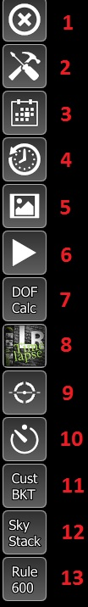
Right side buttons
- Close button – pressing this button will close connection to the connected camera and display the connection screen. If there is another active camera connected the application will switch to that camera device screen
- Connection scrren button – pressing this button will display the connection screen
- Camera properties display button – pressing this button will display the camera properties display where the user can change the camera properties/settings. See ‘Camera properties display’
- Capture history button – pressing this button will display the capture history display. In ’Capture history display’ the last 50 captured images are displayed that where taken with this camera after the application is started
- Image gallery button – pressing this button will display ‘Image gallery’ screen where the user can browse the local and camera SD card images. See ‘Image gallery screen’
- Last capture button – pressing this button will display the last captured image
- DOF calculator button – pressing this button will display the DOF calculator dialog. See ‘DOF calculator’
- LRTimelapse button – pressing this button will display the LRTimelapse screen. See ‘LRTimelapse screen’
- Camera angle button – pressing this button will display the camera angle display that shows the camera roll, yaw and pitch values. See ‘Camera angle display’
- Interval time button – pressing this button will display the application interval timer dialog. See ‘Interval timer dialog’
- Custom bracketing button
  - Single press – will activate and display the custom bracketing screen
  - Long press – will disable custom bracketing if it is enabled
- Sky stacking button
  - Single press – will activate and display the sky stacking screen
  - Long press – will disable sky stacking if it is enabled
- Rule 600 button – will display the ‘Rule 600’ dialog

Bottom display
In the bottom display the current camera settings are display for shutter speed, aperture, ISO etc. From there the user can also change the settings.
- Shutter speed – displays the camera current shutter speed. Pressing this button will display the shutter speed property dialog where the user can change the current shutter speed if the camera current mode allows it.
- Aperture – displays the camera current aperture. Pressing this button will display the aperture property dialog where the user can change the current aperture value is the camera current mode allows it.
- ISO – display the camera current ISO value. Pressing this button will display the ISO property dialog where the user can change the ISO value
- Exposure correction – displays the camera current exposure correction value. Pressing this value will display the exposure correction dialog where the user can change the current exposure correction value if the camera current mode allows it.
- White balance – displays the current white balance camera setting. Pressing this button will display the white balance property dialog where the user can change the current white balance value.
- Lens focal length – display the attached lens current focal length (if the lens support it). This is a Nikon only property.
- Exposure indicator – displays the camera exposure evaluation with the current camera settings
- Remaining free images – displays the camera memory card free space as number of images that can be captured with the current image format settings.
- Battery indicator – displays the camera battery status

Center area
The center area is used to display the camera live view stream, camera properties, capture history, etc.

Live view display
This is where the camera live view stream is displayed
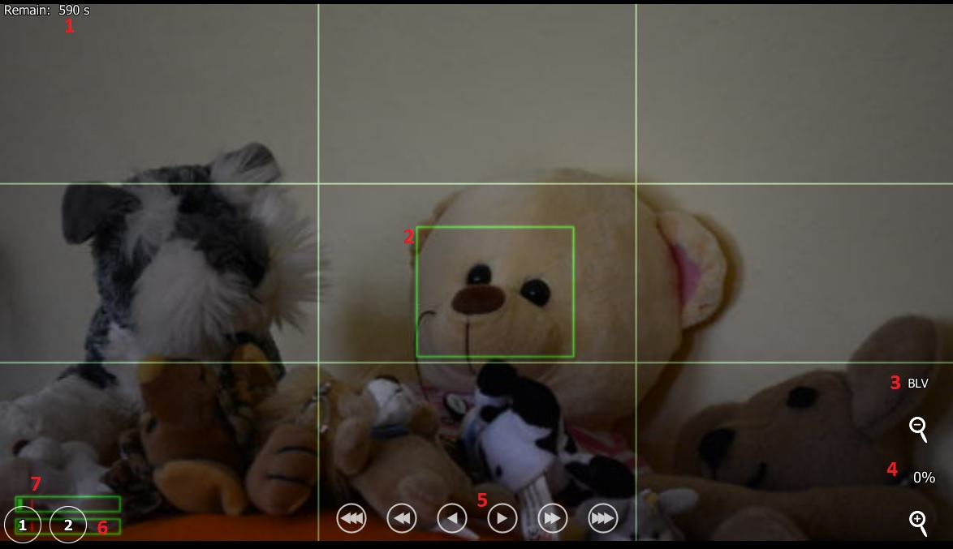
- Live view remaining time – displays the time remaining for using the live view. When the timer reaches 0 the camera will disable the live view. This is a Nikon safety for live view use.
- Focus rectangle – the camera focus rectangle. When the camera auto focus is started the camera will try to focus this region. The user can change the focus rectangle position by touching the live view image surface.
- BLV button – the BLV (bright live view) button can be used to remember the camera exposure settings. After pressing the BLV button qDslrDashboard will remember the exposure settings (shutter speed, aperture, ISO, EV) and after that the user can change these settings to brighten the live view image. After pressing the application capture button qDslrDashboard will restore the remembered exposure values for the capture duration. Pressing again the BLV button will restore the remembered exposure values and disable the BLV mode.
- Zoom in/out buttons – the +/- buttons can be used to zoom in/out the live view image.
- Focus movement buttons – the focus buttons can be used to move the camera lens focus ring. The focus movement can be used while the focus mode is set to AF-S. There are 3 buttons (small, medium, large step) in both direction (closest, infinity). If the button is pressed and hold it will continuously move the focus
- Focus point buttons – the button 1 and 2 can be used to remember the focus position set by user. When the focus point is defined the button will turn red.
  - Single press – if a focus point is defined (the button is red) the application will move the lens focus to the defined position
  - Long press – will remember the current lens focus position. If there is already a focus point defined It will be overwriten
Note: if the users uses the camera AF (auto focus) the defined focus points will be cleared.
Note: with Canon DSLR only one focus step can be used. Always the last step used will be the one that focus point remembers (so if the user used the medium step and defined a focus point then only the medium step can be used again. If another step is used the application will clear the defined focus point)
Note: the focus point buttons will remember the camera lens focus position and not the focus rectangle position (the focus rectangle is only used by camera AF – auto focus).
- Audio level – this will display the camera audio level. The audio level will be only visible when live view is in movie recording mode and if the camera supports it

Camera properties display
The camera properties display is where the camera properties (settings) are display and where the user can change them. The settings are categorized. It will vary depending on the camera model (some have more some less settings). In the explanation I will use the Nikon D7100.
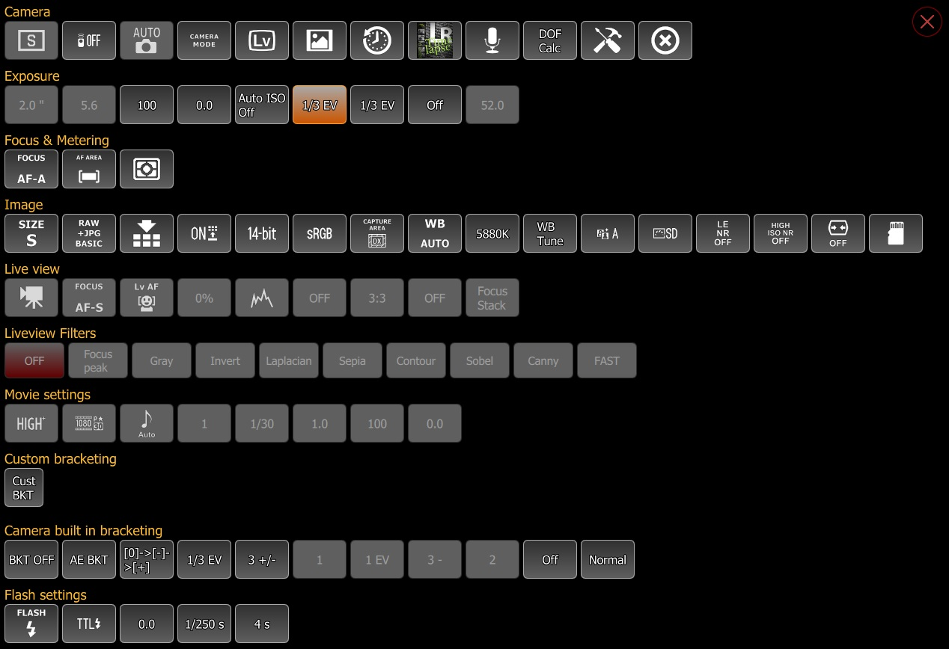

Camera category
The camera contains buttons related the camera exposure mode, release mode, remote release mode and most of the buttons from the right side.
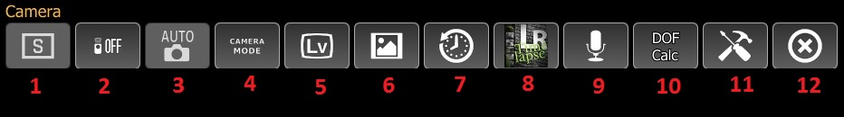
- Exposure operation mode button
- Remote control mode button
- Exposure program mode button
- Host mode button
- Live view button
- Image gallery button (see ‘Image gallery’)
- Capture history button (see ‘Capture history’)
- LRTimelapse button (see ‘LRTimelapse’)
- Sound initiated capture (see ‘Sound inititated capture’)
- DOF calculator
- Connection screen button (see Connection screen)
- Close device (camera) button

Exposure category
In exposure category are all the buttons related to camera exposure like shutter speed, aperture, ISO, exposure correction. The values of the settings can be changed depending on the camera exposure program mode.
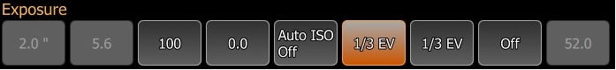

Focus & metering category
The focus & metering category contains buttons related to camera focus mode and metering mode.
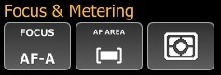

Image category
The image category contains all the buttons that are related to the camera image format, size, compression settings.

Live view category
The live view category contains all the settings related to the camera live view. These buttons are only enabled when the camera live view is enabled.
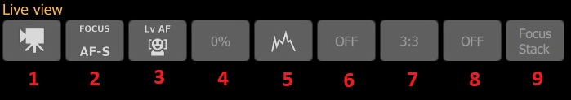
- Live view mode button – with these button the user can switch between live view photography and movie recording mode
- Live view focus mode – with this button the user can change the live view focus mode
- Live view AF area mode – with this button the user can change the live view AF (auto focus) area mode
- Live view zoom – with this button the user can change the live view zoom ratio (the camera will always zoom the focus rectangle area)
- Histogram mode button – with this button the user can change the live view histogram mode. It can be: off, separate histograms, combined histograms
- Live view aspect ratio button – with this button the user can change the live view aspect ratio display
- Live view grid mode button – with this button the user can change the live view grid display mode
- Live view flip mode – with this button the user flip the live view image. It can be off, vertical flipped, horizontal flipped and flip in both directions
- Focus stacking button – with this button the user can enable focus stacking. See ‘Focus stacking’

Live view filters category
The live view filters category contains buttons for various live view filters that can be applied to the live view image. The ‘Focus peek’ when enabled will display the focused parts of the image in red.

Movie settings category
The movie settings category contains buttons that are available while the live view is set to movie recording mode. With these buttons the user can change the movie quality, resolution, exposure settings.
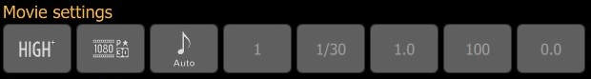

Camera built in bracketing category
This category contains buttons for the camera built in bracketing and HDR capture (if the camera supports it). With these buttons the user can enable/disable the camera built in bracketing and change the settings for it.
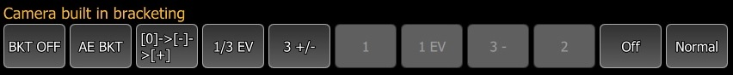

Flash settings category
This category contains buttons for the camera built in and external flash settings. If the camera supports the Nikon CLS this category will contain the buttons for it (unfortunately Nikon does not include the PTP properties for CLS in models after the D7000)
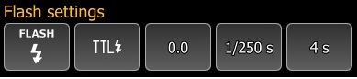

Capture history display
The capture history will display the last 50 captures that where made after qDslrDashboard established a connection with the camera. The user can click on the image to view it in the image viewer. The last capture is always highlighted with a red border. With the ‘Clear’ button the user can clear the capture history.
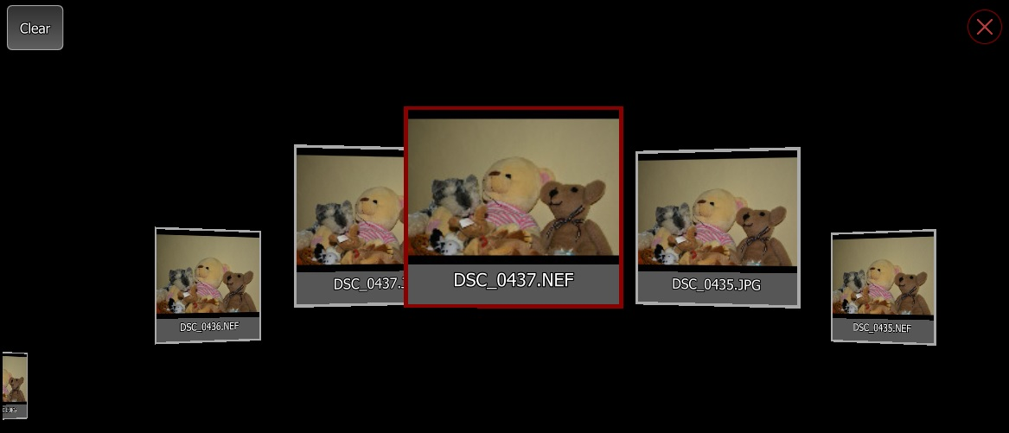

Camera angle display
If enabled it will display the camera angle if the camera supports it. If the camera supports the yaw and pitch properties it will be also displayed.
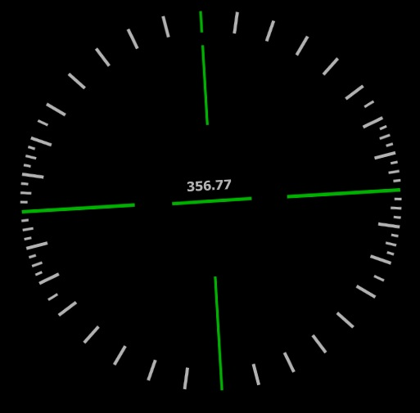

Custom bracketing display
The custom bracketing display will allow the user to capture bracketed images at different EV values. It can work in 2 different modes depending on the connected camera exposure mode.
- M mode – if the camera exposure mode is set to M mode the application will change the camera shutter speed
- A mode – if the camera exposure mode is set to A mode the application will change the camera EV value
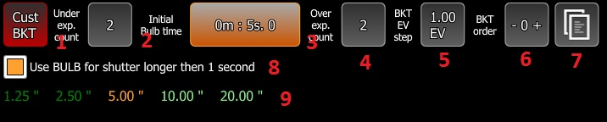
The custom bracketing display buttons:
- Custom bracketing button – with this button the user can disable the custom bracketing
- Under exposure count button – with this button the user can change the count of under exposure images that will be captured
- Initial bulb time – with this button the user can select the initial BULB time if the camera shutter speed is set to BULB
Note: this button is only visible if the camera shutter speed is set to BULB
- Over exposure count button – with this button the user can change the count of over exposure images that will be captured
- EV step button – with this button the user can change the EV step that will be used between the captures
- Bracketing order button – with this button the user can change the order of the custom bracketing capture
- Profile button – with this button the user can open the custom bracketing profile dialog where it can save/load the custom bracketing settings
- Use BULB for exposure longer than 1 second – this checkbox is only visible if the camera shutter speed is set to BULB. If enabled the application will use BULB mode for shutter speeds that are equal or longer than 1 second. If disabled the application will use the connected camera available shutter speeds and BULB for shutter speeds that are longer than 30 second
- Bracketing values - this will display the shutter speed/EV values for the custom bracketing with the current settings

Sky stacking display
With the help of sky stacking display the user can capture series of images that later can be used in application like Deep Sky Stacker
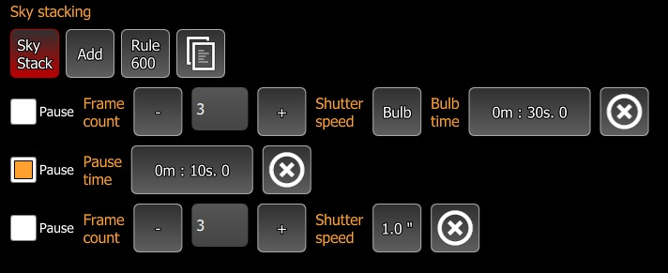
Parts of the sky stacking display:
- Sky stack button – with this button the user can disable the sky stacking
- Add button – with this button the user can add a new sky stacking item
- Rule 600 button – with this button the user can display the Rule 600 dialog
- Profile button – with this button the user can display the profiles dialog for saving/loading the sky stacking settings
Sky stacking item buttons:
- Pause checkbox – when enabled the item will become a pause item and qDslrDashboard will pause for the defined time
- Pause time – with this button the user can set the pause time. This button is only visible if the pause checkbox is enabled
- Frame count – the number of frames that will be captured at the defined shutter speed. With the + /- buttons the user can change the frame count
- Shutter speed – the shutter speed that will be used for this item
- Bulb time – if shutter speed is set to BULB with this button the user can select the BULB time
- Delete item – with this button the user can delete/remove this item

Image gallery screen
In image gallery screen the user can browse/download/delete the local and the camera SD card images.
In local mode the image gallery will display the image thumbnails that are located in the folder the user set in the application settings.
In camera mode the image gallery will display the connected camera SD card images. It will display a ‘folder’ for each SD card the camera has
To view an image the user must click on the image thumbnail.

Image gallery button
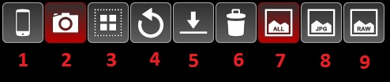
- Local gallery button – this button will switch to the local image gallery. If the local gallery is active the button will be highlighted
- Camera gallery button – this button will switch to camera image gallery. If the camera gallery is active the button will be highlighted like on image above.
- Selection button – this button can be used to switch between image view and selection mode.
  - Single click – will switch the selection mode. If the selection mode is active the button will be highlighted. In selection mode the user can select/deselect images by clicking on the image thumbnails. The selected images will be highlighted
  - Long click – will invert the current selected images, selected images will become unselected and unselected images will become selected. It will also activate selection mode if it wasn’t
- Refresh button – will reload the images information from the local folder or the camera SD card.
Note: downloading the images information from the camera SD card can take some time if there are many images
- Download button – this button can be only used while the image gallery is in camera mode. After pressing it the application will download the selected images from the camera SD card to the local image folder that is set in application settings
- Image filter all – if active the image gallery will display all the images
- Image filter JPG – if active the image gallery will only display the JPG images
- Image filter RAW – if active the image gallery will only display the RAW images

Image viewer screen
In image viewer screen the user can review the captured local or camera image. If the image is from camera SD card the image will be first downloaded to the image folder that is set in the application settings.
The user can pinch zoom (or using the mouse wheel) the image and it can also move around on the zoomed image.
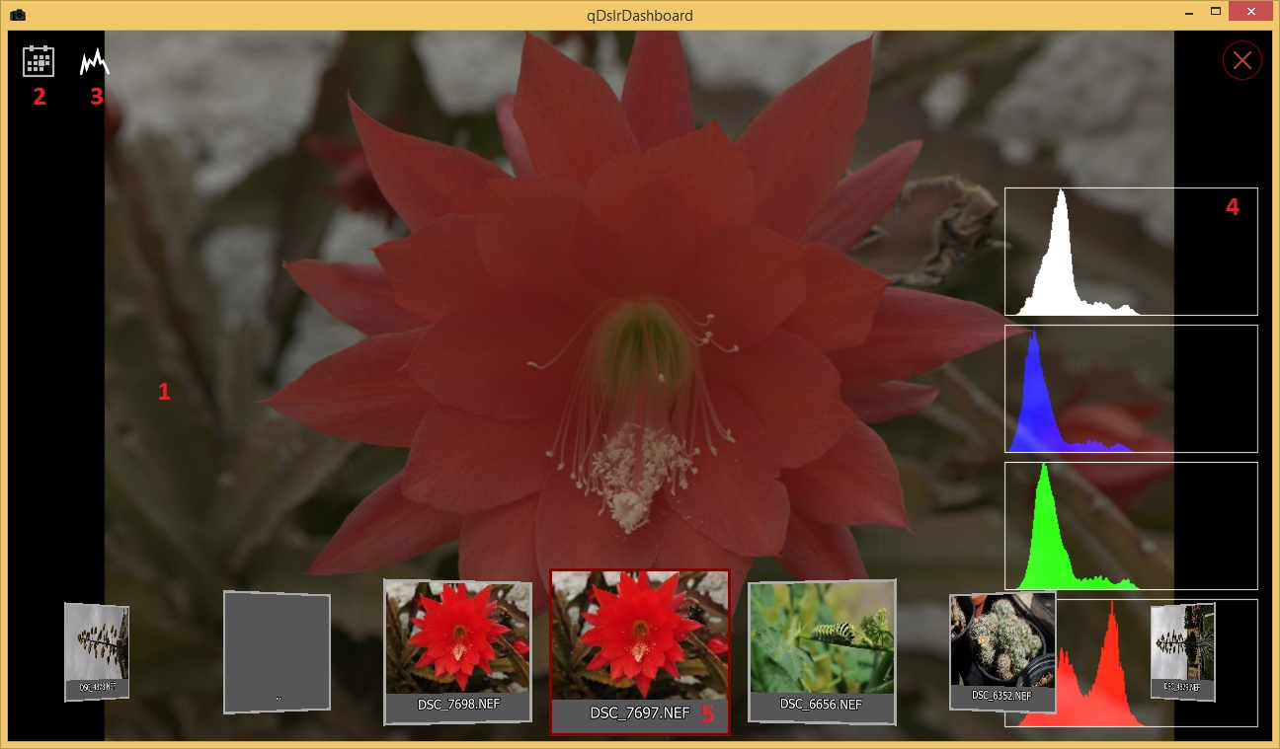
- Displayed image – this is the area where the image is displayed
  - Single click – will toggle between not zoomed and 100% zoom
  - Pinch zoom – will zoom in/out the image
  - Mouse wheel – will zoom in/out the image
  - Hold and move – while zoom will scroll the zoomed image
  - Swipe left/right – will move to next/previous image
  - Double click – will toggle between full screen and windowed mode
- Image controls toggle button – will toggle the image screen controls
- Histogram toggle button – will toggle between the histogram modes. It can be off, separate histograms and combined histograms
- Image histogram – if enabled the image histogram will be displayed here
- Quick browsing – the user can quickly review another image without returning to image gallery. The currently displayed image is highlighted. Depending from where the image viewer was called the quick browsing can be in following modes:
  - Local mode – will display the image thumbnails from the local folder
  - Camera mode – will display the image thumbnails from the camera SD card
  - Capture history mode – will display the image thumbnails from the capture history

LRTimelapse screen
With the help of LRTimelapse screen in qDslrDashboard you can monitor your time-lapse session and eventually make some changes to camera exposure settings if needed. It was made with help of Gunther Wegner the developer of the LRTimelapse application.
By monitoring the histogram when shooting Sunsets/Sunrises and changing Exposure/ISO accordingly from time to time as it gets darker or brighter you will be able to capture time lapses with a huge dynamic range without the need to use HDR, bulp ramping or other complicated and inferior techniques. qDslrDashboard helps you to make all those adjustments without touching the camera and lets you do all you need to via this one, streamlined screen. You will then use the Software LRTimelapse to easily compensate for that adjustments by intelligently tweaking the Metadata of the images and using Lightroom or Adobe Camera RAW and LRTimelapse to render a smooth time lapse transition from day to night without any visible jumps. Please find all information about LRTimelapse and the so called “Holy Grail Method” of time lapse shooting including video tutorials and a free test version on LRTimelapse.

Before the user can enter the LRTimelapse screen there are some prerequisites:
- Camera must be set to M mode so that qDslrDashboard can change the shutter speed/ISO value
- Image format must be set to RAW+JPG. qDslrDashboard will after capture download the JPG image and calculate it’s histogram value. The JPG image is used as it is much faster to download and analyze.
- If the camera supports separate ISO EV step property it’s value must be set to the same value as the EV step property (some higher end Nikon models have separate ISO EV step property)
- Camera Auto ISO control should be turned off

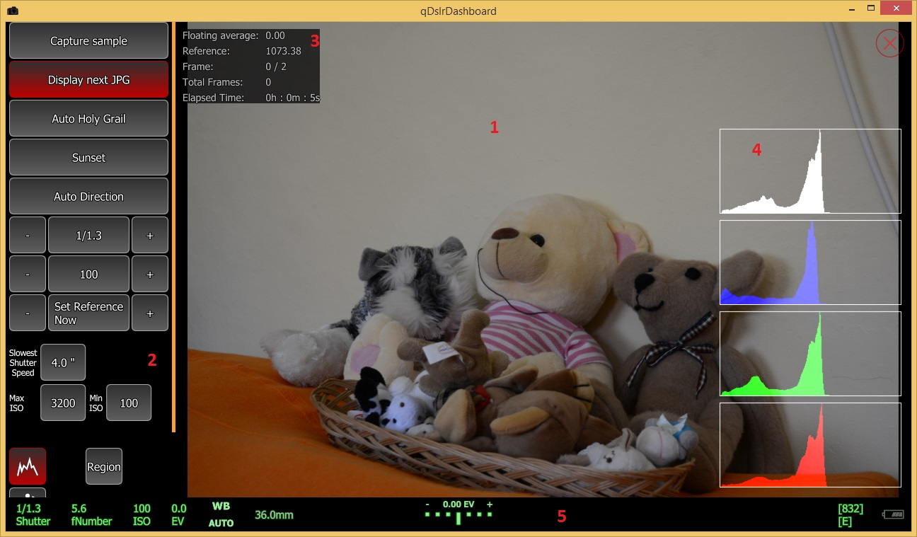
Parts of the LRTimelapse screen are the following:
- Captured image display – this is the area where the captured image is displayed. The user can turn full screen display on/off by single clicking on the image
- LRTimelapse control buttons – with these buttons the user can control how the LRTimelapse screen is working
- Information area – this area contains information about the LRTimelapse session
- Image histogram – the image histogram
- Bottom area – this area contains the same information as described in Bottom display

The LRTimelapse screen buttons

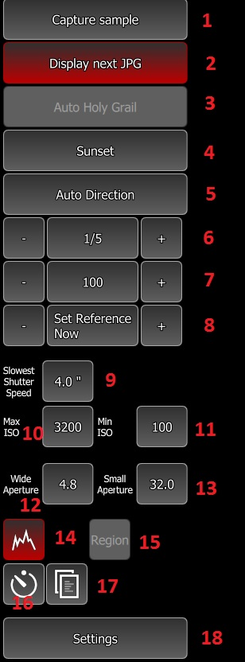
- Capture sample – before the user can enable the ‘Auto Holy Grail’ it must capture an image so that qDslrDashboard can analyze it. It can do with this button or with the camera capture button. After ‘Auto Holy Grail’ is enabled this button will be hidden.
- Display next JPG – if enabled qDslrDashboard will download and display the next capture JPG image.
- Auto Holy Grail – with this button the user can start/stop the ‘Auto Holy Grail’ session. The button is only enabled if a sample capture was made
- Auto Holy Grail direction – with this button the user can change the ‘Auto Holy Grail’ capture direction. Depending on this setting qDslrDashboard will increase or decrease the camera shutter speed or ISO
- Auto direction button – if enabled qDslrDashboard will also do shutter speed/ISO correction in opposite direction then the Auto Holy Grail direction. The user can control with a percentage value when the ‘Auto Direction’ will be performed
- Camera shutter speed – with these buttons the user can change the camera shutter speed. The +/- buttons will increase/decrease the shutter speed by the EV step set in LRTimelapse settings
- Camera ISO – with these buttons the user can change the camera ISO value. The +/- buttons will increase/decrease the ISO value by the EV step set in LRTimelapse settings.
- Reference point buttons – with these buttons the user can change the reference point. The reference point value is used by qDslrDashboard to determine if there is a need for shutter speed/ISO change. With the ‘Set Reference Now’ button the user can set the reference point to the value that was calculated for the last captured image. With the +/- buttons the user can increase/decrease the reference value by 10%.
- Slowest shutter speed – when the Auto Holy Grail direction is set to Sunset qDslrDashboard will change the camera shutter speed until this value is reached, after this it will begin to change camera ISO value
- Max ISO – when the Auto Holy Grail direction is set to Sunset qDslrDashboard will increase the camera ISO value until it reaches this value
- Min ISO – when the Auto Holy Grail direction is set to Sunrise qDslrDashboard will decrease the camera ISO value until reaches this value
- Wide aperture – if aperture ramping is enabled the user can select the widest aperture that qDslrDashboard will use during an Auto Holy Grail session
- Small aperture – if aperture ramping is enabled the user can select the smallest aperture that qDslrDashboard will use during an Auto Holy Grail session
- Image histogram display mode – with this button the user can change image histogram display mode. It can be off, separate histograms and combined histograms
- Region – with this button the user can define an image region that qDslrDashboard will use for histogram calculation. By default the whole image is used
- Interval timer – with this button the user can display the interval timer dialog. From there it can start/stop the interval time. See ‘Interval timer’
- Profile button – with this button the user can open the profile dialog for saving/loading the LRTimelapse screen settings
- Settings button – with this button the user can display the LRTimelapse settings dialog.

LRTimelapse settings dialog
In the LRTimelapse settings dialog the user can change the LRTimelapse settings that regulate the Auto Holy Grail work.
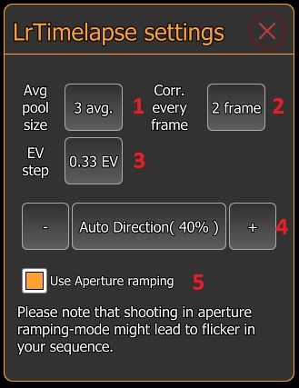
- Average pool size – with this button the user can change the pool size that is used to calculate the floating average. By default it is set to 3 and it means qDslrDashboard will use the last 3 histogram values to calculate the floating average value
- Correction every fram – with this button the user can change the number of frames that need to pass before qDslrDashboard will download the JPG image and calculate it’s histogram value and make changes to camera shutter speed/ISO value if needed. By default it is set to 2 frames meaning qDslrDashboard will download the JPG image for every second capture and analyze it.
- EV step – with this button the user can change the EV step that will be used when increasing/decreasing the shutter speed/ISO value. Also the EV step value is used with the +/- buttons for shutter speed/ISO buttons.
- Auto direction – if ’Auto direction’ is enabled the user can change the ’Auto direction’ percentage here. If the floating average value is smaller or greater (depending on Auto Holy Grail direction) by the percentage set from the reference point qDslrDashboard will perform the shutter speed/ISO value correction in the oposite direction
- Use aperture ramping – if enabled qDslrDashboard will also use the connected camera aperture during an Auto Holy Grail Session
Note: On Nikon D750, D800, D800E, D810, D4 and D4s enabling live view will prevent the aperture from opening in between shots. This will allow you to shoot a flicker free sequence

LRTimelapse information display
In this area various information are displayed about the Auto Holy Grail process
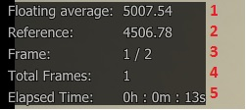
- Floating average – here is displayed the calculated average value from the histogram values in the pool (that was set in LRTimelapse settings dialog)
- Reference – this is the reference histogram value that is used by qDslrDashboard to determine if the is a need for shutter speed/ISO value change. Depending on the Auto Holy Grail direction if the ’Floating average’ value is above/under the ’Reference’ value qDslrDashboard will perform the shutter speed/ISO value change
- Frame – here is displayed the ’current frame’ and ’frame count’ before qDslrDashboard will perform a shutter speed/ISO value change. When ’current frame’ reaches ’frame count’ qDslrDashboard will determine if a shutter speed/ISO value change is required and if needed it will perform the change. The ’current frame’ will be reseted after it reached ’frame count’. If a shutter speed/ISO value change is pending the ’current frame’ will be only reseted if qDslrDashboard succefully changed the shutter speed/ISO value.
- Total frame – this is the count of the total captured frames after Auto Holy Grail is enabled
- Elapsed time – this is the elapsed time after Auto Holy Grail is enabled

Auto Holy Grail workflow
- The user takes a sample image with the ‘Capture sample’ button or with the camera shutter release button. qDslrDashboard will download and analyze the captured image histogram and calculate the reference point for the image that will be displayed in the information display.
- The user sets the ‘Auto holy direction’, ‘slowest shutter speed’, ‘Max ISO’ and ‘Min ISO’ values
- The user enables the Auto Holy Grail process with the ‘Auto Holy Grail’ button
- The user starts the internal or external interval timer
the interval time should be longer by 3-5 seconds (dark time) then the slowest shutter speed that will be used during the time-lapse capture. This ‘dark time’ is needed because qDslrDashboard needs to download the image from camera and it needs to make changes to camera shutter speed/ISO value. While the camera performs the capture qDslrDashboard can’t download the image or change the camera properties. The ‘dark time’ depends on the camera model and the speed of the used SD card. The ‘dark time’ can be lowered by choosing a lower resolution/quality JPG image setting.
NOTE: on Canon DSLR while the camera capture button is half pressed (camera auto focusing) the camera will not accept commands from qDslrDashboard. Some external interval timers perform a ‘half press’ before the interval is over (my does this 3 seconds before the interval is over) so even if the user allowed a 3 second ‘dark time’ qDslrDashboard will not be able to download the captured image or to change the shutter speed/ISO value as the camera capture button will be ‘half pressed’.
- During the Auto Holy Grail session if needed the user can change reference value. It can lower/raise the value with the -/+ button or it can set it to the last calculated value with the ‘Set Reference Now’ button
- If needed the user can enable/disable the ‘Auto Direction’ allowing qDslrDashboard to change the shutter speed/ISO value in both direction

Interval timer
The interval timer will initiate a camera capture at the defined interval. The user can define a desired frame count or leave at 0 then it will repeat until the user stops the timer. The user can also enable interval ramping over a time period.
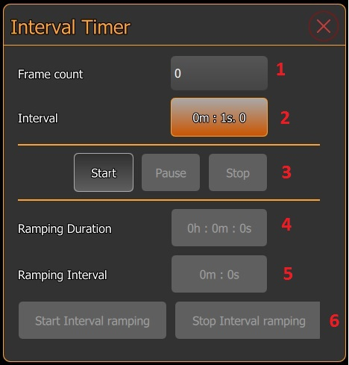
Parts of the interval timer dialog are the following:
- Frame count – if set qDslrDashboard will continue to perform a camera capture until the number of frames is reached. If leaved at 0 it will repeat the camera capture until the user stops the interval timer with the ‘Stop’ button
- Interval – the interval that will be used between the camera captures. The interval is measured from the last camera capture start.
Note: even if qDslrDashboard allows settings 1 second for interval probably this will not work. After a capture is performed by the camera it needs time to write the capture image to the SD card. This depends on camera model, SD card used and image format/size. While the camera does this qDslrDashboard can’t start another capture and in this case it will skip the frame. In my testing a 3-5 second interval is a safe one.
- Interval timer control buttons – with these button the user can start/pause/stop the interval timer
- Ramping duration – is the time at which the interval ramping will be performed. During this time qDslrDashboard will gradually increase/decrease the interval to the ‘Ramping interval’ value.
Note: the user can only change this value after the interval timer is started and the interval ramping is not started
- Ramping interval – is the target interval that will be used at the end of the interval ramping
Note: the user can only change this value after interval timer is started and the interval ramping is not started
- Interval ramping control buttons – with these buttons the user can start/stop the interval ramping. If the interval ramping is stopped the interval will be set to the last interval that was used during the interval ramping
Note: On Nikon DSLR to improve the interval timer before starting the timer put the camera in host mode and set the focus mode to manual (MF) or select manual focus on the attached lens.

Focus stacking
With focus stacking the user can capture images at various focus distances and then combined them into a single image that will have greater depth of field (using a separate software).
Focus stacking in qDslrDashboard is only available while the camera live view is enabled as the lens focus ring can only be moved then.
The focus stacking interface is displayed over the live view image.
After the user set the required parameters for focus stacking the process can be started with qDslrDashboard ‘Capture’ button.
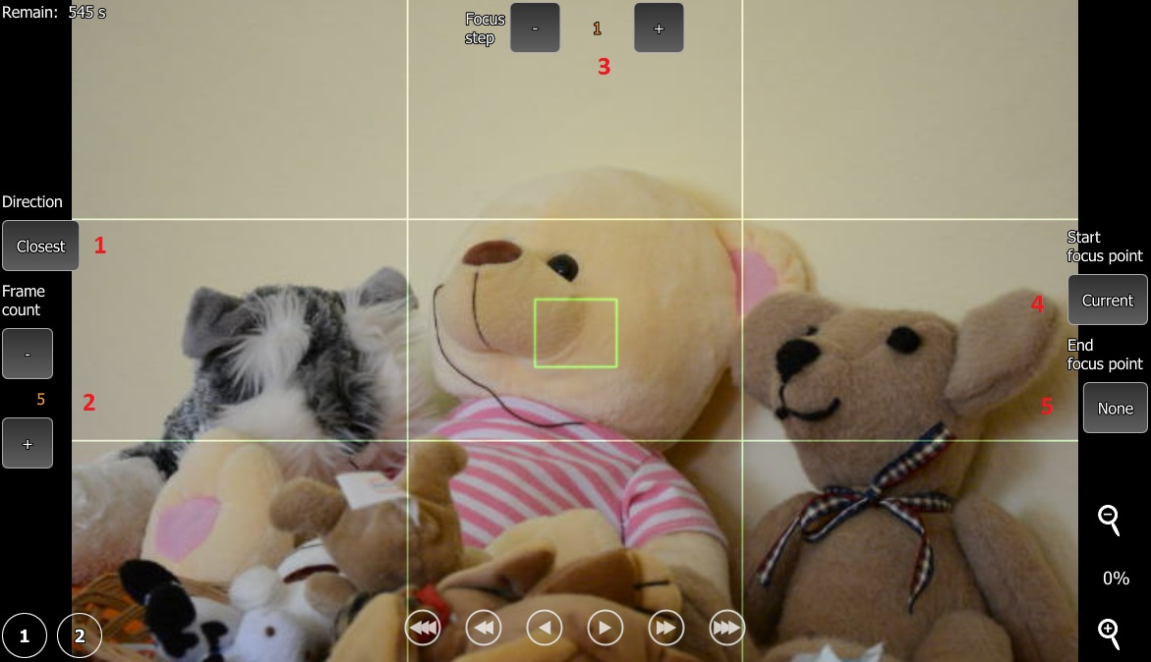
Parts of the focus stacking interface:
- Focus stacking direction – with this button the user can change the focus stacking direction (closest/infinity)
- Frame count – with the +/- buttons the user can set the number of the desired focus stacking images that will be captured
- Focus step – this is the amount of the lens focus ring movement that qDslrDashboard will apply between the captures.
Note: Nikon DSLRs allow a lens focus ring movement in the range of 1 to 32767. In my testing the smallest number that will actually perform a movement is 10. The lens focus ring range is around 1400 but this depends on camera model and the lens used. There is no way to determine the lens focus ring current position or the range.
Note: Canon DSLRs only support a lens focus ring movement in 3 predefined steps (small, medium, large)
- Start focus point – with this button the user can use the predefined focus point (defined with the ‘1’ and ‘2’ buttons) as a starting focus point. If used qDslrDashboard will set the focus stacking direction and the focus step values
- End focus point – with this button the user can use the predefined focus point (defined with ‘1’ and ‘2’ buttons) as the end focus point.
A simple focus stacking workflow:
- User starts the camera live view and enables the focus stacking interface (‘Focus stack’ button under live view category in camera properties display
- Using the live view focus movement buttons the user focuses on the part of the image that will be used as end focus point
Note: after this point the camera AF (auto focus) can’t be used
- User long presses the focus point ‘1’ button so that qDslrDashboard remembers the focus point (focus point ‘1’ button will turn red)
- Using the live view focus movement buttons the user focuses on the part of the image that will be used as start focus point
- User sets the desired focus stacking image count
- User sets the ‘End focus point’ to focus point ‘1’ and leaves ‘Start focus point’ at current (qDslrDashboard will set the focus stacking direction and focus step values)
- Users starts the focus stacking capture with the ‘Capture’ button

Audio capture dialog
With the help of the audio capture a camera capture can be started by sound that is monitored on the device microphone where qDslrDashboard is running.
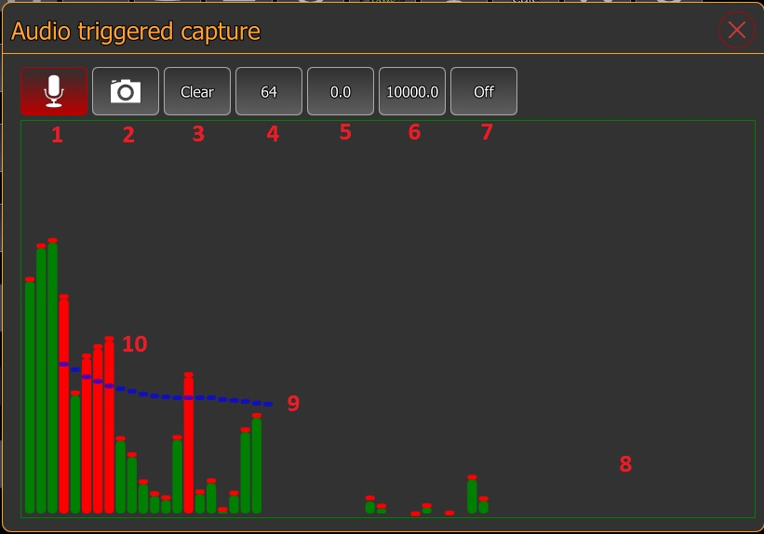
Parts of the audio capture dialog are:
- Audio on/off button – with this button the user can turn on/off the device microphone monitoring
- Camera capture enable/disable button – with this button the user can enable/disable the camera capture. While disabled the capture will be not performed if the sound level reaches the defined value, this can be used to test the defined values
- Clear button – will clear the defined audio capture values from the spectrogram
- Number of the spectrograph bars – with this button the user can change the number of the spectrograph bars
- Low frequency – with this button the user can change the low frequency value. Values under this value will be discarded
- High frequency – with this button the user can change the high frequency value. Values over this value will be discarded
- Spectrograph window function – with this button the user can change the window function that will be used by spectrograph (http://en.wikipedia.org/wiki/Window_function )
- Spectrograph display – in this area is displayed the analyzed sound spectrograph
- Audio capture level – the user can define here the level for each frequency that will cause a camera capture. If the monitored sound frequency is over this value the capture will be performed. The user can set the frequency values by holding down the left mouse button and moving the mouse or on touch screens by touching the screen and moving the finger
- Frequency level reached – the red spectrograph bars indicate that the monitored sound frequency is over the user defined level

Nikon white balance tuning
With the help of this dialog the user can tune the white balance on Nikon DSLR.
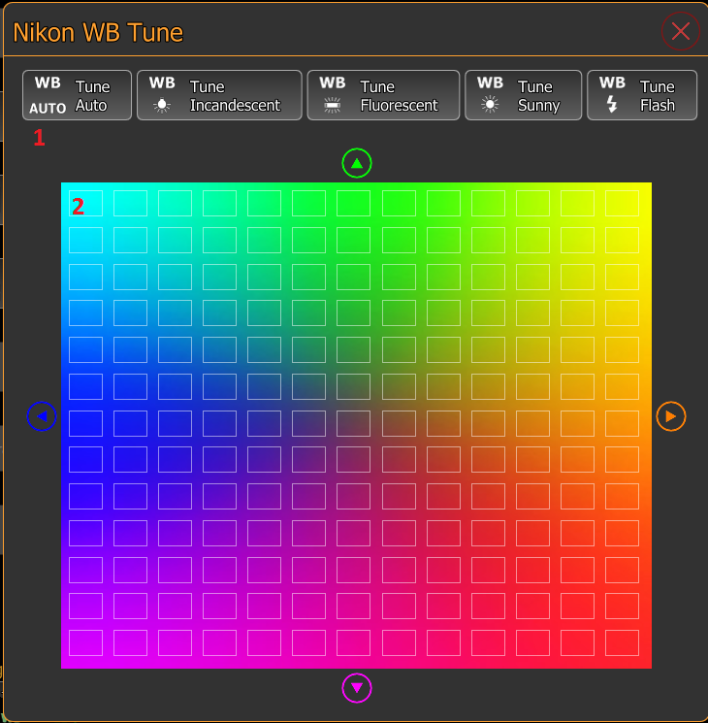
Parts of the Nikon white balance dialog are:
- White balance type selector – here the user can select the white balance type for which it wants to tune the value. This is a list of buttons and can be scrolled horizontaly.
- Color cube – the color cube that is used to fine tune the white balance type. The color cube is enabled after the user selects the white balance type
After the user selected the white balance type the dialog interface will change to
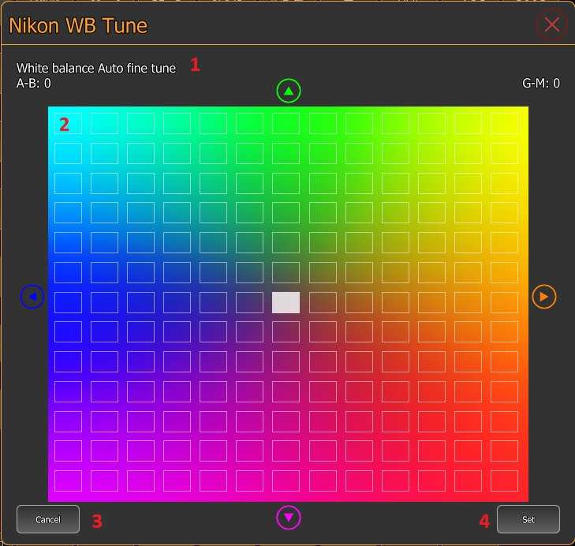
Parts of the dialog for setting the white balance color value
- White balance type name – the white balance type name that is fine tuned
- Color cube – the color cube where the user can fine tune the white balance type color value. It can do simply by clicking on any of the rectangles or using the arrows on the side
- Cancel button – with this button the user can cancel the white balance fine tuning
- Set button – with this button the user can set the defined value

DOF Calculator dialog
With the help of the DOF Calculator dialog the user can calculate the Depth of field
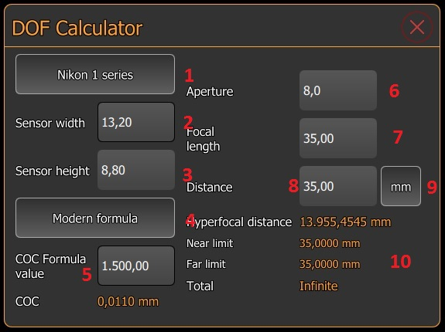.
Parts of the DOF Calculator dialog
- Sensor size button – with this button the user can select the camera sensor size that will be used in calculation
- Sensor with – in this field the user can enter the camera sensor width in millimeters
- Sensor height – in this field the user can enter the camera sensor height in millimeters
- Circle of Confusion formula button – with this button the user can select the ‘Circle of Confusion’ formula that will be used in Depth of Field calculation
- Circle of Confusion formula value – in this field the user can enter the ‘Circle of Confusion’ formula value
- Aperture – in this field the user can enter the aperture value that will be used for Depth of Field calculation
- Focal length – in this field the user can enter the lens focal length that will be used for Depth of Field calcutlation
- Distance to subject – in this field the user can enter the distance to subject that will be used for Depth of Field calculation
- Distance unit button – with this button the user can change the measurement unit for the distance value
- Depth of Field calculation result – in this area is displayed the calculated Depth of Field values

Rule 600 calculator dialog
With the ‘Rule 600’ dialog the user can calculate the slowest shutter speed for the given focal length that will not cause star trails.
Some explanation about it: http://starcircleacademy.com/2012/06/600-rule/
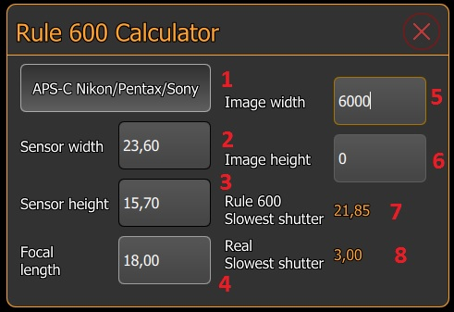
Parts of the ‘Rule 600’ dialog
- Sensor size button – with this button the user can change between the predefined camera sensor sizes
- Sensor width – the camera sensor width in millimeters
- Sensor height – the camera sensor height in millimeters (not used in calculation)
- Focal lens – the desired lens focal length in millimeters
- Image width – the captured image width in pixels (used for real slowest shutter calculation)
- Image height – the captured image height in pixels (not used in calculation
- Rule 600 slowest shutter speed – the calculated slowest shutter speed before star trails will show using the ‘Rule 600’ formula (600 / focal length) for full frame camera. qDslrDashboard will calculate it according the selected camera sensor size
- Real slowest shutter speed – the calculated slowest shutter speed before star trails will show using the d = t * f / 13750 (please read this article: Rule 600? )
Note: the ’Image width’ field must be populated so that the ’Real slowest shutter’ can be calculated

DslrDashboard server (ddserver)
Ddserver is a small open source application that can forward PTP packets over network between qDslrDashboard and the USB connected camera. It can handle multiple connected cameras (using USB hub).
It can run on Linux or OSX devices. It can be used on the wireless router like TP-Link MR3040 (http://www.tp-link.com/en/products/details/?model=TL-MR3040 ) running OpenWrt (https://openwrt.org/ ) or other devices that run OpenWrt (like the Arudino Yun - http://arduino.cc/en/Main/ArduinoBoardYun?from=Products.ArduinoYUN )
Using the MR3040 (or other compatible devices) with ddserver allows qDslrDashboard to wirelessly remote control the camera that is connected to the MR3040 with USB.
The ddserver source can be found here: https://github.com/hubaiz/DslrDashboardServer

Flashing OpenWrt DDSERVER onto TP-Link MR3040
Before the TP-Link MR3040 can be used with qDslrDashboard and DslrDashboardServer it first must be flashed with the OpenWrt DDSERVER firmware. There are 2 versions of the MR3040 and the correct firmware should be downloaded. The version is printed in the battery compartment and can be checked by removing the battery.
The latest version of the OpenWrt DDSERVER firmware can be found always at: http://dslrdashboard.info/downloads
NOTE: before beginning the MR3040 flashing fully charge the battery
NOTE: flashing the MR3040 is best done with a wired network connection to the user PC or notebook (best is when the MR3040 is the only network device connected to the PC/notebook)
NOTE: for the first flashing (MR3040 has the TP-Link firmware) the ‘factory’ image is needed
A detailed manual for flashing the OpenWrt onto MR3040 with images from Gunther Wegner can be found here: http://lrtimelapse.com/gear/dslrdashboard/
Steps required for flashing:
- Download the correct version (V1, V2) of the ‘factory’ image for the MR3040 from http://dslrdashboard.info/downloads
- Connect the MR3040 to your PC/notebook with a wired network cable and turn it on
- From you PC/notebook web browser access the MR3040 web interface located at http://192.168.0.1 (the default username/password is admin/admin)
- In the left side menu select ‘System tools->Firmware upgrade’
- Select the OpenWrt DDSERVER image file that you downloaded in step 1
- Press the ‘Upgrade’ button to start the flashing
- Wait 4-5 minutes while the flashing is performed. Monitor the MR3040 LEDs. At the end of a flash the LED’s should go off and the on.
- From your web browser access the OpenWrt web interface located at http://192.168.1.1
- Set a ‘root’ password
- The default wireless access point name is DDSERVERAP

Upgrading the TP-Link MR3040 OpenWrt DDSERVER firmware
The user should follow this guide if his TP-Link MR3040 has already the OpenWrt firmware on it and there is a new version of the OpenWrt DDSERVER firmware.
Note: the ddserver package version can be checked by accessing the OpenWrt web interface from a web browser at address http://192.168.1.1 and then navigating to ‘System->Software’ The latest ddserver package version V0.2-13
NOTE: before beginning the MR3040 flashing fully charge the battery
NOTE: for the firmware upgrade (MR3040 has already the OpenWrt firmware) the ‘sysupgrade’ image is needed
Steps required for upgrading the OpenWrt firmware:
- Download the correct version (V1, V2) of the ‘sysupgrade’ image from http://dslrdashboard.info/downloads
- Connect the MR3040 to your PC/notebook with a wired network cable and turn it on
- From the PC/notebook web browser access the OpenWrt web interface at http://192.168.1.1
- In the OpenWrt web interface select the ‘System->Backup/Flash firmware’
- Under ‘Flash new firmware image’ section press the ‘Choose file’ button and select the OpenWrt ‘sysupgade’ image downloaded in step 1
NOTE: if the ‘Keep settings’ checkbox is checked the current MR3040 settings will be preserved
- Press the ‘Flash image’ button
- In the upcoming confirmation screen press the ‘Proceed’ button to start the flashing (upgrading) process
- Wait 2-3 minutes while the flashing is performed. At the end of the flashing the router will reset itself and reboot (LEDs will go out)
- From a web browser access the OpenWrt web interface at http://192.168.1.1 and under ‘System->Software’ check the ‘ddserver’ package version, it should match the downloaded firmware version

Upgrading the OpenWrt ddserver package with the package updater
The ddserver package updater allows updating the ddserver package on the MR3040 without the need of flashing the device firmware again.
NOTE: This will only work if your MR3040 already has the OpenWrt firmware.
You will need a Windows machine connected to MR3040 (wireless or wired connection will work), the MR3040 root passowrd (you was asked to change the root password the first time you accessed the OpenWrt web interface) the MR3040 IP (192.168.1.1 by default).
If you didn’t set a root password yet then open your web browser and enter http://192.168.1.1 as address (your PC should be connected to MR3040). On the web page you get you will have a link where you can change the ‘root’ password (to login just press the ‘Login’ button and leave the ‘password’ field empty)
Steps to update the ddserver package with package updater:
- Download and unpack the ddserver package updater from http://dslrdashboard.info/downloads
- Open a command prompt (hit Win+R and enter cmd)
- Navigate to the folder where you unpacked the ddserver package updater (cd \temp\ddserver_package_unpacker)
- enter the following: update_ddserver.bat root_password 192.168.1.1 ddserver_0.2-13_ar71xx.ipk
- hit Enter
Where
- root_password – is the root password you set on the MR3040
- 192.168.1.1 – is the IP address of the MR3040 (this is by default, if you changed you should know to what did you change)
- ddserver_0.2-13_ar71xx.ipk – this is the actual ddserver package for the MR3040 (and other ar71xx devices)
The output should look something like this:
d:\temp\ddserver>update_ddserver.bat root_password 192.168.1.1 ddserver_0.2-13_ar71xx.ipk
d:\temp\ddserver>pscp.exe -scp -l root -pw root_password ddserver_0.2-13_ar71xx.ipk 192.168.1.1:/tmp
WARNING - POTENTIAL SECURITY BREACH!
The server's host key does not match the one PuTTY has
cached in the registry. This means that either the
server administrator has changed the host key, or you
have actually connected to another computer pretending
to be the server.
The new rsa2 key fingerprint is:
ssh-rsa 1039 8c:14:93:7c:8f:ac:b6:1d:3a:29:af:f3:2b:8b:d9:13
If you were expecting this change and trust the new key,
enter "y" to update PuTTY's cache and continue connecting.
If you want to carry on connecting but without updating
the cache, enter "n".
If you want to abandon the connection completely, press
Return to cancel. Pressing Return is the ONLY guaranteed
safe choice.
Update cached key? (y/n, Return cancels connection) y
ddserver_0.2-13_ar71xx.ip | 10 kB | 10.3 kB/s | ETA: 00:00:00 | 100%

d:\temp\ddserver>plink.exe -ssh -l root -pw root_password -batch 192.168.1.1 /et
c/init.d/ddserver stop; opkg remove ddserver; opkg install /tmp/ddserver_0.2-13_
ar71xx.ipk; /etc/init.d/ddserver start; rm /tmp/ddserver_0.2-13_ar71xx.ipk
Stoping DslrDashboardServer (ddserver)
ddserver stoped
Removing package ddserver from root...
Installing ddserver (0.2-13) to root...
Configuring ddserver.
Starting DslrDashboardServer (ddserver)
Saving PID 1727 to /var/run/ddserver.pid
DslrDashboard server started

If you get the ‘WARNING – POTENTIAL SECURITY BREACH!’ message just press the ‘y’ key and Enter.
After the update is finished you can check in OpenWrt web interface if the update was a success. Open a browser window and enter http://192.168.1.1 as address. Login with your MR3040 ‘root’ password and navigate to System->Software.

Frequently asked question (FAQ)

What camera will work with qDslrDashboard?
With qDslrDashboard you can control Nikon and Canon DSLR. Nikon models from D40 and up to latest one will work. The D3000, D3100, D3200, D3300 models will also work but they are budget models with limited set of PTP commands (live view is only available on D3200 and D3300).
Canon DSLR from the EOS line should work.
Recent version of qDslrDashboard will work with Sony models that support wireless connection (a7 models, NEX5, NEX6, a5000, a5100, a6000) – this is still in development

Does my Android device have USB host function?
For USB connection to work your Android device needs to have the USB host function and an USB OTG adapter. Unfortunately not all manufacturers include/enable the USB host function. Here is a nice article that can help determine if your Android device has the USB host function: http://android.stackexchange.com/questions/36887/how-can-i-determine-if-my-device-has-usb-host-mode-otg-support

Will USB connection work on iOS devices with the Camera Connection Kit?
Unfortunately it will not work as the ‘Camera Connection Kit’ API is not available for developers. On iOS devices only wireless connection will work with the camera built in wireless or with the TP-Link MR3040 solution (or any other wireless router that can run OpenWrt and ddserver).

Are wireless SD cards supported (Eye-fi)?
No, wireless SD card only allow image transfer and no camera control.

Can you add support for Pentax, Fuji, Olympus etc camera?
I would love to add support to those cameras but unfortunately none of the vendors releases documentation for developers (only exception is Nikon and recently Sony). Without documentation I would need a physical camera to try and figure out the PTP commands/properties the camera supports .

